Scorpius

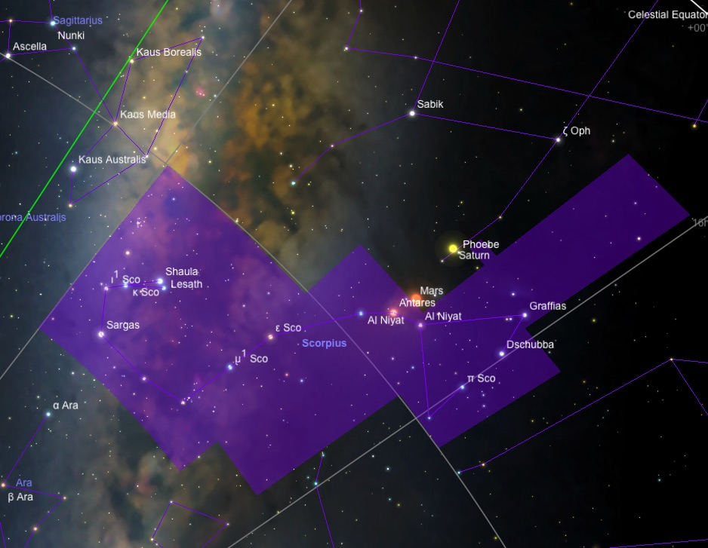

Scorpius - The Scorpion
Scorpius lies between Libra and Sagittarius. It appears as a looping curve of stars which forms the stinging tail of a scorpion. Scorpius lies in the western part of the Milky Way and contains many objects worth viewing. It is best seen from June to August.

History and Mythology
Scorpius was listed by the Greek astronomer Ptolemy in the second century AD. In Greek mythology, there are two main justifications for Scorpius' existence in the heavens. In the first, Orion was a great hero of large stature who was given the privilege of hunting with the goddesses Artemis and Leto. While hunting on Crete, Orion boasted he could kill any animal on Earth. Gaia took offense and cracked open the earth, from which a scorpion emerged to kill Orion. In the second, Orion attempted to forcibly break Artemis' vows of chastity. So threatened, Artemis summoned the scorpion that killed Orion. Because of his heroism in life, in both tales Zeus was asked to place Orion into the heavens. Zeus put Orion into the sky but found it fitting to put the scorpion in the sky as well. To this day, it is said that Orion is still running from the beast that killed him with its deadly sting. This is reflected in Orion descending or "running away" as Scorpius is rising. Both are ancient fables elucidating the cost of hubris. Scorpius has already set in autumn as Orion rises, and as Scorpius rises in the summer Orion has already set in the western horizon.

Notable Stars
The heart of Scorpius is the red giant star Antares, meaning "rival of Mars". It is the 15th brightest star in the sky. It is a red supergiant star about 550 light-years away; its diameter measures 400 times that of the Sun, and it is 10,000 times brighter than the Sun. It is a semi-regular variable, with fluctuating magnitudes of 0.9 - 1.1. Antares is a well-known double star, with a hot blue fifth magnitude companion appearing 2.9 arcseconds away. Their orbital period is roughly 900 years.

Despite having the Bayer designation Lambda Scorpii, Shaula is the second brightest star in Scorpius, and the 24th brightest star in the night sky. Its traditional name comes from the Arabic phrase meaning "stinger", as it is found in the tail of the scorpion. It is actually a triple star system, though unresolvable in small telescopes, consisting of three hot blue stars 365 light-years away. Upsilon Scorpii, or Lesath, is the other star making up the Scorpion's stinger; a hot blue star physically similar to Shaula, it is about 180 light-years close.

The double star Beta Scorpii (Acrab or Graffias, meaning "scorpion" or "claws") is in the front part of the scorpion. It is much easier to split with small telescopes. It has blue-white components of magnitude of 2.6 and 4.9, separated by 14 arcseconds. Both are hot, massive, blue-white class B stars at least ten times as massive as our Sun; both are expected to end their lives as supernova explosions.

Theta Scorpii, Sargas or Girtab, is the third brightest star in Scorpius at magnitude 1.9. It is a yellow giant shining from a distance of 270 light-years.

Delta Scorpii, or Dschubba, is the middle of the three-star line that makes the head of the Scorpion. Dschubba means the "scorpion brain" or "forehead", and it is a blue-white star of magnitude of 2.3. Originally fifth-brightest in the constellation, it began to brighten in 2000, and became a first magnitude star, the second-brightest in the constellation, in 2003-2004. As of 2008, it remains in an erratic state near magnitude 2.1, about 0.2 magnitudes brighter than normal.

Clusters, Nebulae, and Galaxies

There are many globular clusters in Scorpius. M 4 can be seen with binoculars and displays a central "bar" of eleventh magnitude stars in small telescopes. It is one of the closest globulars to the Sun, at 7,200 light-years away.

Globular Cluster M4. Jim Misti.
Located halfway between Antares and Acrab is the globular cluster M 80. It is a compact globular cluster, and can be easily seen in a small telescope.

M 6 and M 7 are two bright open clusters which are naked eye objects. M 6 is known as the "Butterfly Cluster". This description comes from the arrangement of the stars into a butterfly-like figure with a body and two wings. It is located above the scorpion's tail. M 7, also known as Ptolemy's Cluster, is much larger and appears as a fuzzy spot against the Milky Way background. It appears twice the size of the moon.

NGC 6231 is a bright open star cluster located near Zeta Scorpii with a total magnitude of 2.6. NGC 6231 is 5,900 light-years away, and belongs to the Scorpius OB association of very young stars.

An interesting planetary nebula in Scorpius is the Bug Nebula, NGC 6302. It is an unusual object that has two protruding nebulous lobes.

* Alpha Scorpii - Antares
Antares is the brightest star in the constellation Scorpius and the sixteenth brightest star in the sky, at magnitude 1.06. It marks the heart of the Scorpion.

History and Mythology

Antares takes its name because of its distinctly red color, which compares to that of Mars. The Greek name Antares means "Rival of Mars", the god of war. The Romans called the star Cor Scorpionis, meaning Heart of the Scorpion. However, they had been anticipated in this by the Assyrians, Babylonians, and Sumerians, who for at least two millennia had also known the star as the Heart of the Scorpion. Many of the old Egyptian temples are oriented so that the light of Antares plays a role in the ceremonies performed there.

Properties

Antares is a red supergiant star of spectral class M2 Iab, with a low surface temperature of about 3,500 degrees. Antares is about 550 light years from us and has an absolute magnitude of -5.1. Its visual luminosity is about 9,900 times the Sun's, but because the star radiates a considerable part of its energy in the infrared, its total luminosity is roughly 65,000 times the Sun's. The star's radius is 3.4 AU, or about 400 times the Sun's. Its large size and relatively small mass give Antares a very low average density. The star contains 15 to 18 solar masses, and probably does not have much time left to it (astronomically speaking).

Companion

Antares is a well known double star. Its hot blue companion star is of spectral type B2.5 V, at a separation of about 2.9", or 550 AU at Antares' estimated distance. The orbit is poorly known, with an estimated period of 878 years. The companion is often described as greenish due to contrast effects, but it is difficult to see in small telescopes due to Antares' glare. On rare nights when conditions are perfect, Antares is one of the most beautiful of all doubles: a tiny emerald point touching the edge of a brilliant reddish-orange disk. Antares B can be observed with a small telescope for a few seconds during lunar occultations while Antares itself is hidden by the Moon. The companion, contains around 7 to 8 solar masses, just below the supernova limit, and will probably die as a massive white dwarf.

* Theta Scorpii - Sargas
At magnitude 1.87, Theta Scorpii is the third brightest star in the constellation Scorpius. Its traditional name, Sargas, comes to us from Sumerian rather than Arabic or Greek.

Sargas is the most southerly bright star in Scorpius, anchoring the southern curve of the scorpion's tail, and is invisible north of latitude 50° N. The star's southerly position allows northern observers to use its visibility as a test of the night-sky brightness near the horizon.

Properties

Scorpius is filled with bright blue-white stars of class B; Sargas is an exception. It is a yellow giant of spectral type F1 II, shining with a luminosity of 960 suns from a distance of 272 light years. Its radius is 20 solar radii, and its surface temperature is 7200 K. The mass of Sargas has been determined to be 3.7 times the Sun's.

Evolution

There is no question that Theta Scorpii is rapidly evolving with a dead helium core toward lower temperatures. One hundred million years ago, it was a class B star like many of its neighbors in the constellation. As the star swells and its surface cools, it should become a Cepheid variable in under a million years, and then become a red giant five times brighter than it is now. At this point, the helium in its core will begin to fuse to carbon and oxygen, setting the stage for it to become a massive white dwarf.

* Mars

Mars is the fourth planet from the Sun, and has been known since ancient times for its reddish color. Mars is named after the Roman god of war, and takes that name from its color. Perhaps because its bloody hue, its close proximity to Earth, and its seasonally-changing surface features, Mars has played a larger role in human culture and mythology than any other planet.

Since ancient times, Mars has been identified with battle, blood, courage, fierce dedication, aggression and victory. The Green name for Mars is Ares. The names chosen in modern times for Mars's two tiny moons, Phobos ("fear") and Deimos ("terror"), refer mythologically to the horsemen of Ares, and make an astronomical link to the ancient Apocalyptic Horsemen.

In Norse mythology and wider Germanic paganism, Tiw or Tyr was a one-handed god associated with combat and pledges. The second day of the work week, Tuesday, gets its name from an Old English word meaning "Tiw's day". The name is based on Latin dies Martis, "Day of Mars"; compare: French mardi, Spanish martes, and Italian martedi.

Orbit and Observation

Mars orbits the Sun at about 1.5 times the average distance of the Earth, with a an orbital period of 687 days. Mars's orbit eccentricity (0.0934) is about six times greater than the Earth's, so its distance from Earth varies widely - from 59 million km at a "favorable" opposition near the orbit's perihelion, to 399 million km at superior conjunction near its aphelion. Because of this, Mars varies greatly in its apparent size, from 3.5 to 25 arc seconds, and in brightness from magnitude -2.9 to +1.7.

In a small telescope, Mars shows many of the surface features that sparked the imagination of science fiction writers. Prominent white polar caps are visible, as are odd dusky markings on its surface. These markings show that Mars rotates once every 24 hours and 37 minutes - so its day is almost the same length as Earth's. Mars also has an axial tilt very similar to Earth's, and has seasons like the Earth. The polar caps shrink and expand during the Martian summer and winter, and the dark patterns on its surface also display seasonal changes. Mars has an atmosphere with sparse clouds, and exhibits occasional dust storms which sometimes grow to cover the entire planet's surface for a few weeks.

The first spacecraft mission to fly by Mars (Mariner 4, in 1965) revealed a vast, barren wasteland of craters. Mars's atmosphere was only 1% as dense as Earth's at the surface, and composed of 95% carbon dioxide (with small percentages of nitrogen and argon). There was no protective ozone layer, and no magnetic field to shield the surface from deadly solar radiation. Its surface was cold - the average temperature is -81° F (-63° C), with a minimum of -200° F (-140° C), and a maximum of 68° F (20° C) on the warmest days at the equator. These conditions made the surface of Mars completely inhospitable to life as we know it. The large number of craters seemed to indicate that Mars was a dead world, geologically speaking, as well.

Diagram of the Martian atmosphere.

However, subsequent spacecraft exploration showed that Mars was perhaps not quite such a dead place after all. Mariner 9, which entered orbit around the planet in 1971 and mapped its surface in high detail for the first time, revealed the presence of huge volcanos and vast canyon systems. The tallest of the volcanoes, Olympus Mons ("Mount Olympus"), is about 17 miles (27 km) high - about three times the elevation of Mount Everest! - and is 340 miles (550 km) across at its base. Olympus Mons is both the largest volcano and the tallest mountain in the solar system, and is aptly named for the home of the gods.

The deepest and longest canyon system on Mars is Valles Marineris (the "Mariner Valley"), and is up to 4 miles (7 km) deep, 120 miles (200 km) wide, and 3000 miles (5000 km) long. It is the largest known crevice in the solar system, and if placed on Earth, it would span the entire United States. Mars was clearly home to some significant geological activity in its past.

Of 38 launches from Earth in an attempt to reach Mars as of mid-2012, only 19 have succeeded - a failure rate of 50%. This high failure rate is informally called the "Mars Curse", and is sometimes facetiously used to "explain" recurring difficulties in reaching the Red Planet.

Water on Mars

More importantly, spacecraft images showed surface features that seemed to indicate the presence of water: channels, dry riverbeds, and flood plains. Features such as these look strikingly similar to features on Earth which have been created by liquid water. But on Mars, unlike Earth, liquid water is all but nonexistent today.

Currently, most of Mars's water is buried beneath the surface or frozen as ice in the polar caps. Mars's permanent polar caps are made of water ice; the seasonal expansion and contraction of the polar caps is actually due to the presence of carbon dioxide ice freezing out of the atmosphere - Mars's polar regions never become warm enough for water to melt.

The first spacecraft to successfully land on Mars (Viking 1, in 1976) detected minute trace amounts of water vapor in the atmosphere. Later missions, particularly NASA's Spirit and Opportunity rovers which landed on Mars in 2004, confirmed that the Martian surface was once covered by abundant amounts of liquid water. The Opportunity rover photographed mineral formations, dubbed "blueberries", which could have only formed in the presence of liquid water.

The Mars Phoenix mission, which landed near Mars's north polar region in 2008, may have photographed deposits of water ice directly under the lander itself. These ice deposits were revealed when the lander's rockets blasted away the overlying topsoil. Later, photographs showed what appeared to be droplets of liquid water condensing briefly on the lander's legs, before evaporating into the thin, dry atmosphere.

Life on Mars?

The Viking landers of the 1970s carried experiments to detect the presence of life. They looked for organic compounds in the Martian soil; they introduced a liquid nutrient solution into the soil and looked for gases released by metabolizing organisms; and they traced the release of metabolic gases from nutrient solution labelled with radioactive carbon-14.

The first two experiments failed to detect any organic molecules or metabolic gas exchange. But the third experiment detected a steady stream of radioactive gases from the soil. Unfortunately, subsequent attempts failed to generate the same results, and today's majority opinion is that the Viking landers failed to conclusively detect life.

Currently, the prevailing view is that chemical reactions with the Martian soil explain Viking's results. A sufficiently strong oxidizing molecule would react with the water Viking added to produce oxygen and hydrogen, and with the nutrients to produce carbon dioxide. The Martian soil, continuously exposed to ultraviolet light from the Sun, has built up a thin layer of a very strong oxidant. In 2008, the Phoenix lander detected perchlorate (a strong oxidizer) in the Martian soil, supporting the chemical interpretation of Viking's results. But as recently as 2011, some scientists argue for a biological interpretation, i.e. that Viking really did find life. It may be best to say that while Viking did not conclusively prove the existence of life on Mars, it did not conclusively disprove it, either.

Meteorites from Mars have landed on Earth, blasted from the Red Planet's surface by enormous asteroid impacts. Preserved in Antarctic ice, these meteorites are known to have originated on Mars, because the composition of gases trapped inside their porous interiors exactly matches that of the Martian atmosphere.

One particular Martian meteorite discovered in Antarctica in 1984, called ALH84001, became the subject of great controversy in 1996. That year, NASA scientists announced that amino acids and other organic compounds had been discovered inside ALH84001. They also showed images of microscopic structures inside the meteorite, resembling (but much smaller than) fossilized bacteria on Earth. These discoveries were first announced as solid evidence that life had actually arisen on Mars. But this conclusion was immediately disputed by other scientists, who argued that the evidence could also be explained by non-biological processes. The situation is unresolved, and in late 2009 some scientists reasserted that Martian meteorites still provide strong evidence of life on ancient Mars.

Earth-based observations of Mars in 2003 revealed trace amounts of methane in the Martian atmosphere. Methane is quickly destroyed in the Martian atmosphere in a variety of ways, so this discovery indicates that some ongoing process is releasing the gas. Much of the methane in Earth's atmosphere is released by living organisms as they digest nutrients. However, other purely geological processes, like vulcanism and the oxidation of iron, also release methane. Right now, we don't have enough information to tell whether biology or geology - or both - are producing methane on Mars.

To confuse the situation further, NASA's Mars Science Laboratory (MSL), nicknamed "Curiosity", has so far failed to detect any methane in the Martian atmosphere. Curiosity landed on Mars in August 2012, inside Gale crater near Mars' equator - a site that had been selected from orbital photos which showed evidence of a habitable environment in the past. During its first year on Mars, Curiosity began driving toward Mount Sharp, a sediment-covered, 3-mile-high peak at the center of Gale crater. Researchers confirmed that liquid water persisted on the crater floor millions of years ago. While Curiosity has not yet found any evidence of life, more results are expected as the complex data from NASA's most ambitious Mars mission have yet to be analyzed.

The evidence is clear that Mars once had a much warmer, wetter past. There is a possibility that life once existed, or still exists, on Mars. Because of that possibility, Mars remains a primary target of our space exploration.

Moons of Mars

Mars has two tiny moons, Phobos and Deimos. Both moons were discovered by Asaph Hall in 1877. Both are tidally locked with Mars, always showing the same face to the planet; and both orbit Mars very close to the plane of its equator. Phobos and Deimos are both small rocky bodies, resembling asteroids. This has fueled speculation that they actually are captured asteroids.

The main alternative hypothesis is that Phobos and Deimos accreted in their present positions, perhaps from material ejected by an impact on Mars - similar to the prevailing theory for the origin of the Earth's Moon.

